Press Release

Tianbing Li
Layers of Time

December 13, 2012– February 23, 2013

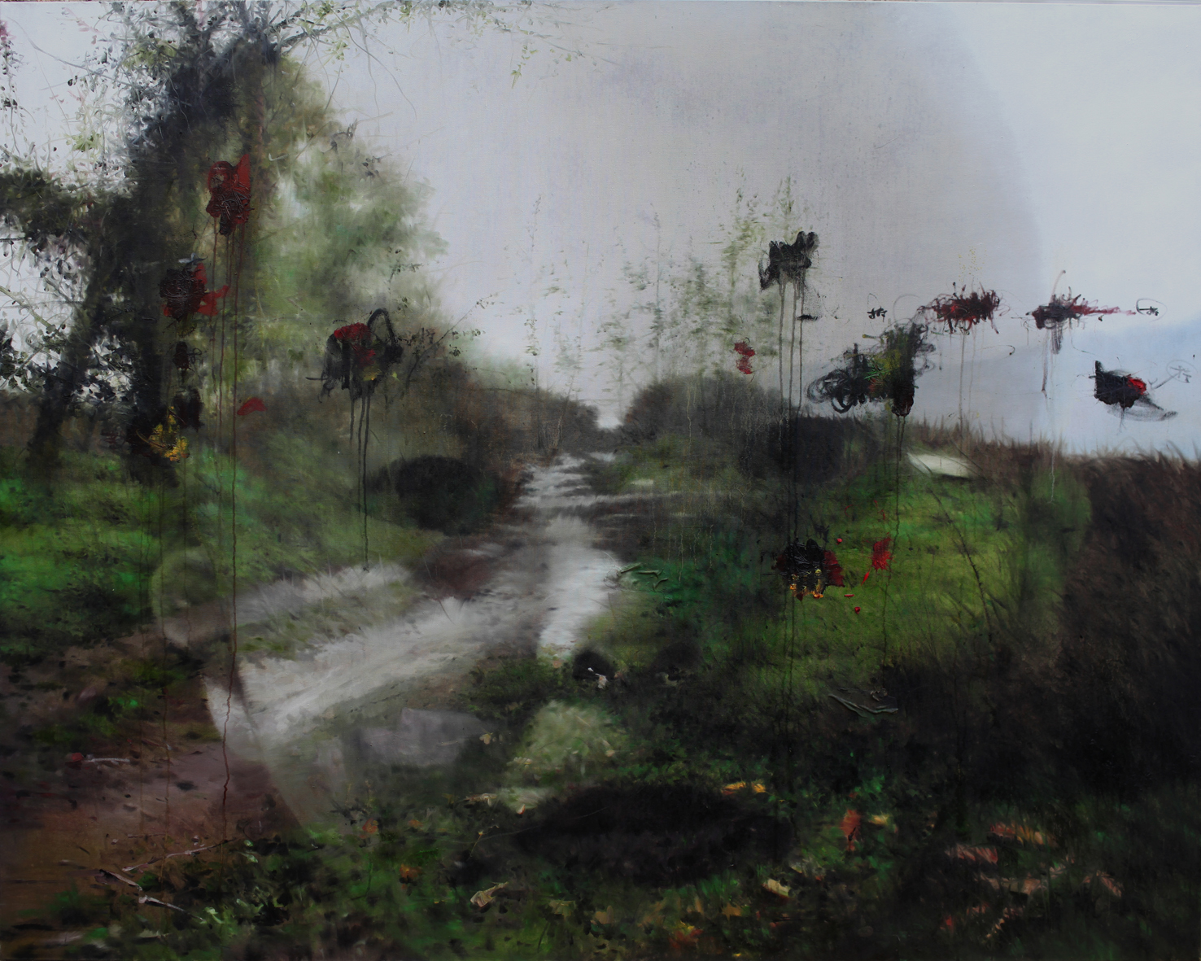
Li, Tianbing, Self-portrait Route, 2011-12, 160 x 200 cm, oil on canvas

Galerie Kashya Hildebrand is pleased to present new works from Tianbing Li in his third solo exhibition with the gallery. His paintings, which are inspired by five black and white photos taken by his father when he was a child, reflect both the emotional and physical landscape of his youth. The paintings continue to explore how China’s one-child policy shaped both his childhood and those of his generation. The works express the deep seclusion and profound psychological implications of the policy, confronting its long-term implications for China’s socio-cultural condition. His practice of representing the interplay between imagination and lived experiences– portraying a child in real environments, sometimes alone and sometimes accompanied by a gang of imaginary brothers and imaginary playmates – has met with considerable critical success.
The evolution of his practice over the past decade reflects an ongoing engagement with the implications of public policy on human lives, but it also reflects a broadening concern and an attempt to create a distinct visual language (one that draws on Chinese techniques and contemporary Western references) for understanding, expressing, and embodying how Chinese culture is changing. The title of the exhibition, Layers of Time, highlights Li’s effort to weave past, present, and future together in his current works. Indeed, the works compellingly reflect aspects from his childhood in the 1970s with aspects of contemporary China.
For example, in Self-portrait Route (pictured), Li constructs a fictionalized landscape from his memories of his hometown of Guilin. The unpopulated rural scene seems almost idyllic; however, the rapid industrialization of the city has changed the actual landscape so dramatically that this kind of scene no longer exists. Nevertheless, he superimposes his own image onto the work as a way of testifying for and claiming the site before it disappears forever from the collective unconscious.
In Layers of Time, Li constructs a world by piecing together its surroundings, building a narrative out of fragments of reality as well as images from the parallel possible worlds he created in his desolate childhood. However, the works move beyond his personal history in order to interrogate China’s recent cultural history. In the end, Li’s layering technique and conflation of environments from different time periods establishes a productive site of communication. His commentary on contemporary China is cautionary, and he positions his work to interrogate the friction between perceived openness and the desire for control. Li’s work offers an important voice in understanding China’s power and its global importance.

Li Tianbing (b. 1974, Guilin, China) lives and works in Paris, France and Beijing, China.
Recent solo exhibitions include: My Imaginary Siblings, Stephen Friedman Gallery, London, UK (2012); A Game as a Pretense of Being, Hong Kong Art Center, Hong Kong, China (2011) curated by Demetrio Paparoni; Childhood Fantasy, Contrasts Gallery, Shanghai, China (2010); Me and my Brother, L&M Arts, New York, USA (2008).
Recent group exhibitions include: Surreal versus Surrealism in Contemporary Art, Institute VAM, Valencia, Spain curated by Gianna Mercurio and Demetrio Paparoni (2011); Sport in Art - Today Art Museum, Beijing, China (2008); Museum of Contemporary Art, Shanghai, China (2007); National Museum of Fine Arts, Beijing, China (2007).

The artist will be present at the opening reception:

Thursday, December 13, 2012 from 6–8pm

Press release and images may be downloaded under:
http://www.kashyahildebrand.org/zurich/press/layers

For further information please contact:

Galerie Kashya Hildebrand, Talstrasse 58, 8001 Zurich, Switzerland
Tel +41 44 210 02 02 Fax +41 44 210 02 15 jolaine@kashyahildebrand.org
www.kashyahildebrand.org

